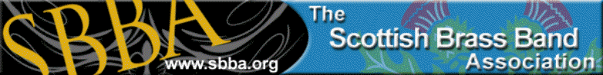
Scottish Open Solo and Ensemble Championship for Brass & Percussion
Sunday 3rd February 2019 in The Howden Park Centre, Livingston EH54 6AE
ENTRY FORM
The Solo part of the competition will be adjudicated in Instrument categories, i.e. Cornet(inc Sop), Flugel, EbHorn, Euphonium, Baritone, Trombone, Bass Trombone, Eb Bass, Bb Bass and Percussion.
From the winner of each instrument category a Champion of Champions will take the title of
Scottish Solo Champion who will be invited to perform as guest soloist for SBBA.
All soloists will also be invited to compete in an open Slow Melody Section.
The ensemble section is open to any instrumentation up to 5 players to become Scottish Ensemble Champion
The event is open to all ages and there will be a prize for the highest placed over 40 soloist.
Timings soloists 6 minutes – ensemble 8 minutes
Entries to Ann Murray annmurray37@hotmail.co.uk
Entry Fees, £5 for soloist £10 for Ensemble, can be paid direct to SBBA account
Bank details. - Bank of Scotland. - SBBA General fund
Sort Code 80-08-85 Account No. 00797191
Soloist Entry Please indicate if you also wish to enter slow melody
Name | Instrument | DOB | Fee | Slow Melody
Brass Ensemble Entry
Name of Ensemble | Instrumentation | Fee
Duet Section | Names & Instrumentation | Fee

Percussion Ensemble entry
Name of Ensemble | Fee

Percussion Solo
www.sbba.org.uk
Name | Instrument | DOB | Fee

